1. Online Giving (via your computer):
a. Cut and paste the following URL into web browser: https://secure.accessacs.com/access/memberlogin.aspx?sn=11149
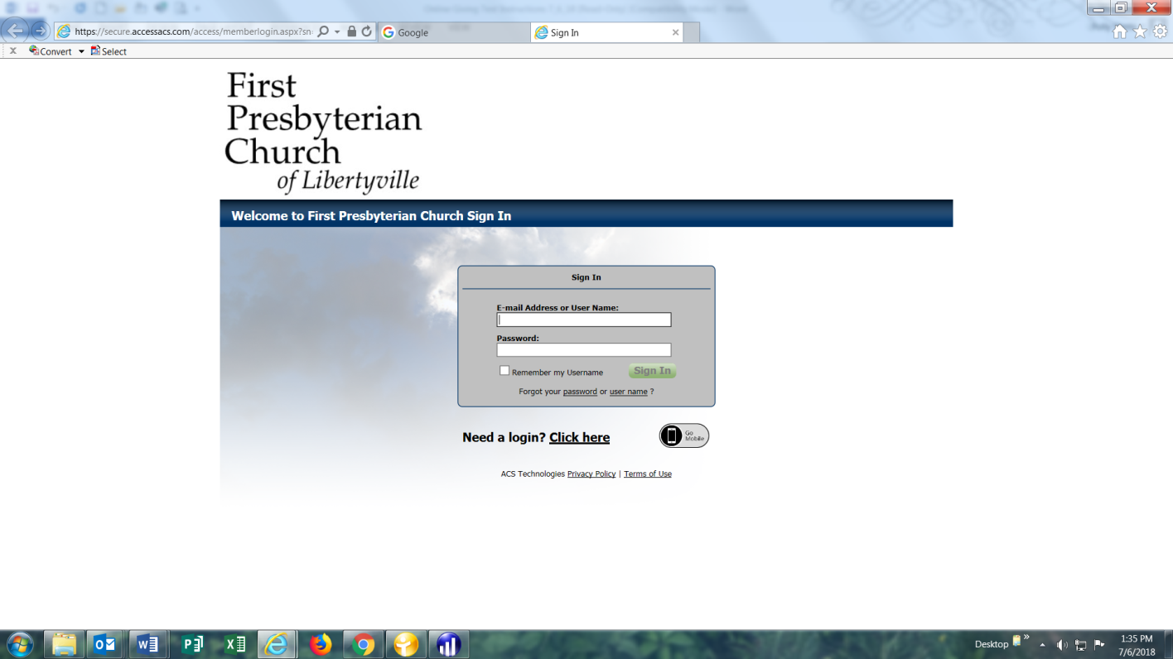

b. If you already have established a logon for EFT giving, log on by entering your email address and password. If you are a new user and have never set-up an account, go to ‘Need a login? Click here’ If you have any problems creating an account, contact Polly Vente in the church office. Once you have a login ID and password, please follow the instructions in the email you will receive from ACS.
c. At the top of the page beneath "First Presbyterian Church of Libertyville," you should see "Welcome, Your Name."
d. Just below the welcome is a blue header bar. Please familiarize yourself with the information shown here. Then click "Giving" at the far right of the blue bar, then click on "Online Giving."
e. Complete all the fields under "New Gift Details" and "Payment Details."
f. Click on the "Give" button to finalize the transaction.

2. Mobile Giving: Please be sure to complete the Online Giving process above to establish your logon and password BEFORE attempting Mobile Giving. You will need a smart phone for this step.
a. Go to the App Store and search for ACS Church Life and download the App.
b. Open the Church Life App and log on using your ID and Password created in step 1 above.
c. Complete the required fields to initiate your gift.
3. QR Code Giving: Again, you will need a smart phone for this step.
a. Go to the App Store and search for QR Code Reader. Download the App.
b. Open the QR Code Reader App and scan the following image:
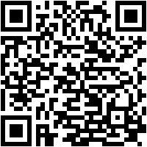
c. You should see "Welcome to First Presbyterian Church." Complete the required fields and press "Continue."
d. On the following page you can continue as an established user (given your completion of step 1 above) or continue as a guest. As a guest, you will need to enter a credit or debit card to complete the transaction.

4. Text to Give: Not sure, but you will probably need a smart phone for this step.
a. Text "Firstpreslib" to 73256.
b. You should receive a reply with a link. Click on the link.
c. You will see a green screen. Complete the required fields and press the green "Give" button at the bottom of the page to complete your transaction.
Thank you and blessings,

Polly Vente Bill Chapman
847.362.2174 847.456.8647
pvente@boxp.net williamdchapman99@gmail.com

